INSERT INTO dbo.Employee ( FirstName, LastName)

VALUES

('John', 'Smith'),

('Jane', 'Doe'),

('Alex', 'Johnson'),

('Emily', 'Davis'),

('Michael', 'Brown'),

('Sarah', 'Lee'),

('Chris', 'Miller'),

('Laura', 'Wilson'),

('David', 'Garcia'),

('Anna', 'Martinez');

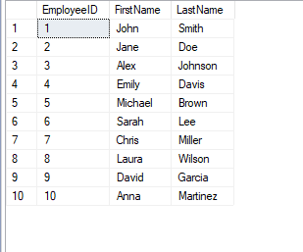

INSERT INTO dbo.Project(FirstName, LastName)

VALUES

('Building', 'Long'),

('House', 'White'),

('Road', 'Good'),

('Shlong', 'Black'),

('Auschwitch', 'Brown'),

('Adolfus', 'Building'),

('Hilter', 'Headquarters'),

('Ben', 'Dover'),

('Red', 'Balls'),

('Deez', 'Nutz');

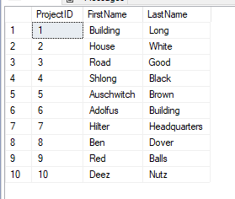

INSERT INTO dbo.ProjectEmployee(EmployeeID)

VALUES

(1),

(2),

(3),

(4),

(5),

(6),

(7),

(8),

(9),

(10);

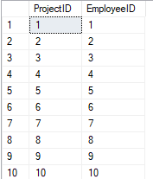

INSERT INTO dbo.ProjectSpecialists(SpecialistID)

VALUES

(1),

(2),

(3),

(4),

(5),

(6),

(7),

(8),

(9),

(10);

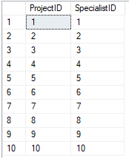

INSERT INTO dbo.Specialist(Specialization)

VALUES

('Electrician'),

('Mechanic'),

('Builder'),

('Plumber'),

('Lumberjack'),

('Miner'),

('Driver'),

('Specialist'),

('Chef'),

('Group Leader');

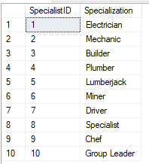

SELECT e.FirstName, e.LastName, p.FirstName

FROM dbo.Employee e

JOIN dbo.ProjectEmployee pe ON e.EmployeeID = pe.EmployeeID

JOIN dbo.Project p ON pe.ProjectID = p.ProjectID;

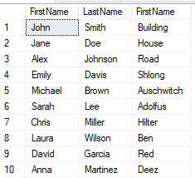

SELECT p.FirstName, s.Specialization

FROM dbo.Project p

JOIN dbo.ProjectSpecialists ps ON p.ProjectID = ps.ProjectID

JOIN dbo.Specialist s ON ps.SpecialistID = s.SpecialistID;

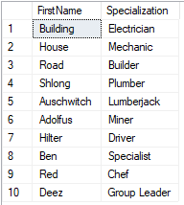

SELECT e.FirstName, e.LastName, p.FirstName, s.Specialization

FROM dbo.Employee e

JOIN dbo.ProjectEmployee pe ON e.EmployeeID = pe.EmployeeID

JOIN dbo.Project p ON pe.ProjectID = p.ProjectID

JOIN dbo.ProjectSpecialists ps ON p.ProjectID = ps.ProjectID

JOIN dbo.Specialist s ON ps.SpecialistID = s.SpecialistI

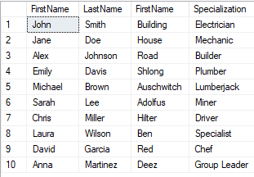

CREATE PROCEDURE GetAllEmployees

AS

BEGIN

SELECT \* FROM dbo.Employee;

END

exec GetAllEmployees

